Erasmus+ Exhibition at Sukromna zakladna skola Felix

Felix School, in collaboration with Bratislava City Council, will host an in-person multiplier event at Felix School at 14:00 on Wednesday 29th June. The event will consist of an exhibition and short presentation to explain the Erasmus+ project – Empathy for Children that Felix school has participated in over the last two years. The meeting is to be addressed by the internationally renowned educationalist, psychologist and author Iben Sandahl. The exhibition is an open event, and all are welcome.

On the same day, a transnational project meeting for the Erasmus+ Empathy for Children project will be led by Bratislava City Council and include project partners from Sukromna Zakladna Skola Felix Bratislava (SK), Infomedia Formazione Ferrara (IT), ECECE Klagenfurt (AT) and the Institut za Raziskave in Razvoj Utrip Zavod (SL). The project partners will also attend the exhibition at Felix school.

These events mark the conclusion of the Erasmus+ Empathy for Children project with the completion of E4C toolkit and E4C Guidelines which provide tools to aid in the successful implementation of Iben Sandahl’s innovative methodologies at both school and government level.

The project's toolkit was developed in collaboration with Iben Sandahl. Iben Sandahl's writings (www.ibensandahl.com) have been featured in Vanity Fair, Huffington Post, The Wall Street Journal, The Washington Post, Psychology Today, The Greater Good Science Center Berkley and in every National Newspapers in Denmark. Her book: The Danish Way of Parenting (what the happiest people in the world know about raising confident, capable kids) has been translated into 31 languages. Iben Sandahl is also the author of Play - the Danish Way & Hold my Hand.
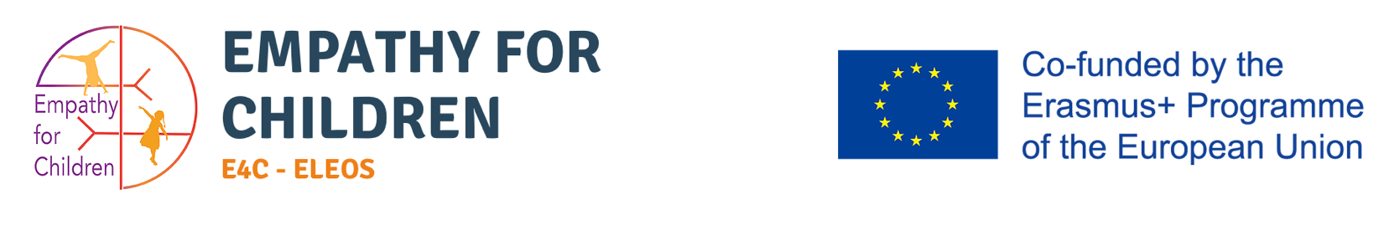

The European Commission 's support for the production of this publication does not constitute an endorsement of the contents, which reflect the views only of the authors, and the Commission cannot be held responsible for any use which may be made of the information contained therein.
